Extended Response Sample Questions

Sherlock Holmes was a great detective who solved crimes by noticing clues others missed. After reading “The Nest of Memories,” explain how Tommy is like Sherlock Holmes.

Using specific details from the passage, explain how an oil spill can affect the food chain in the ocean.

Explain how humans and bacteria worked together to clean up the oil spill. Use specific details from the passage to support your answer.

Explain how the speaker’s point of view, or attitude, influences the way that John Snow’s life and work is presented in the poem. Use specific details from the poem “John Snow” to support your answer

Part A Explain one way that John Snow’s work with cholera and Edward Jenner’s work with smallpox were alike. Part B Explain one way their work was different. Use details from both poems to support your answers.

In “Memoir—Benjamin Franklin,” Franklin briefly tells about seeing a young woman after arriving in Philadelphia. “The Life of Benjamin Franklin” tells about the couple’s first meeting in a different way. Explain one way the two presentations are different. Use details from both passages in your explanation.

Refer to the Underdrawings section of “Renaissance Painting Today.” Part A Describe how paragraph 3 fits into the Underdrawings section. Part B Explain how paragraph 3 contributes to the development of the entire passage. Use details from the passage to support your explanation.

Both “The Renaissance Artist” and the passage “Renaissance Painting Today” discuss Renaissance art and Leonardo da Vinci. Compare and contrast the information presented in each. Use details from both “The Renaissance Artist” and “Renaissance Painting Today” to support your response.

Using “Jamie’s Journal” and “Mount St. Helens,” compare and contrast Mount St. Helens and Spirit Lake both before and after the eruption on May 18, 1980.

The poet describes Nathan Stubblefield as an aspiring “philanthropist” and a “genius farmer.” Based on the information in “Extreme Genius,” explain whether those terms accurately describe the inventor. Use examples from the poem and the passage in your explanation.

Making a comparison of the poem and the informational paragraph, explain how the life circumstances and personality of Nathan Stubblefield contributed to his misfortune. Use relevant details from both the poem and the passage to support your explanation.

Henry David Thoreau was a nineteenth-century American author, poet, and philosopher best known for his desire to simplify his life by relying on himself. He went into the woods to live away from the pressures of society. He is well-known for this statement. “If a man does not keep pace with his companions, perhaps it is because he hears a different drummer. Let him step to the music which he hears, however measured, or far away.”
Explain how Pedro’s situation and actions in the story compare to Thoreau’s words. Use at least two specific details from the story to support your response.

From reading “Letters from Underground,” describe the differences between Amos and Jim White as he is described in Amos’s letters. Use details from the passage to support your explanation.

Based on what you learn about both men from the letters and the passage, explain how their reactions to and appreciation of the caves conflict. Use details from both the letters and the passage to support your explanation.

Read the text, look at the pictures, and answer the question below. Using evidence from the text and pictures to support your response, describe the history of China during the time of Emperor Qin (Ch’in), explain why the Great Wall was built, and describe what these pictures show about the culture of China at that time.

North America is the world third largest continent. In your ANSWER DOCUMENT, identify two major physical features of North America. Then, for each feature you identified, describe its characteristics.

Flagstone Middle School pays for new band instruments with profits from its vending machines. The biggest seller is Monster Cola. But a recent survey reports that drinks with caffeine, such as Monster Cola, may cause children’s sleep problems. Flagstone’s principal wants to remove Monster Coal and other caffeinated drinks from the school’s vending machines.
In your ANSWER DOCUMENT, identify one possible disadvantage of the principal’s decision and explain why it is a disadvantage.
identify one immigrant group that came to North America in the past three hundred years. Then explain one reason why that group decided to come come here.
describe two lasting effects of the English colonization of North America.
identify two branches of the United States government. Then, describe the main responsibility of each branch identified.
Cultural groups meet basic human needs in a variety of ways. Such basic needs include the need for food, clothing, shelter and artistic expression.
In your ANSWER DOCUMENT, take one of these needs and then compare how two different cultural groups in North America have met that need.
identify one right and one responsibility enjoyed by American citizens. Then show how each right and responsibility selected helps keep our government democratic.

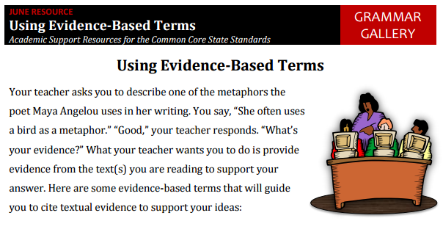
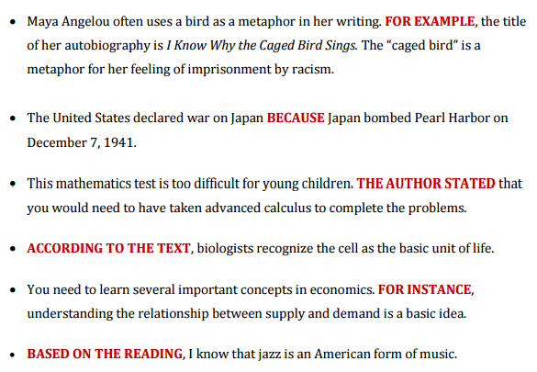

Caged Bird
BY MAYA ANGELOU
A free bird leaps
on the back of the wind
and floats downstream
till the current ends
and dips his wing
in the orange sun rays
and dares to claim the sky.

But a bird that stalks
down his narrow cage
can seldom see through
his bars of rage
his wings are clipped and
his feet are tied
so he opens his throat to sing.

The caged bird sings
with a fearful trill
of things unknown
but longed for still
and his tune is heard
on the distant hill
for the caged bird
sings of freedom.

The free bird thinks of another breeze
and the trade winds soft through the sighing trees
and the fat worms waiting on a dawn bright lawn
and he names the sky his own

But a caged bird stands on the grave of dreams
his shadow shouts on a nightmare scream
his wings are clipped and his feet are tied
so he opens his throat to sing.

The caged bird sings
with a fearful trill
of things unknown
but longed for still
and his tune is heard
on the distant hill
for the caged bird
sings of freedom.
Evidence Based Writing Prompt:

